How to Access Exam Information in the Edulink App
Open up the App and click on the ‘Exams’ tab.

There are currently two options – Exam Timetable and Exam Entries. This is what the timetable looks like at the moment. You will be able to find information about the dates, times and length of each exam. Rooms and seat numbers will be allocated by Easter. You can click on the ‘Download’ button to print off a copy of your timetable.
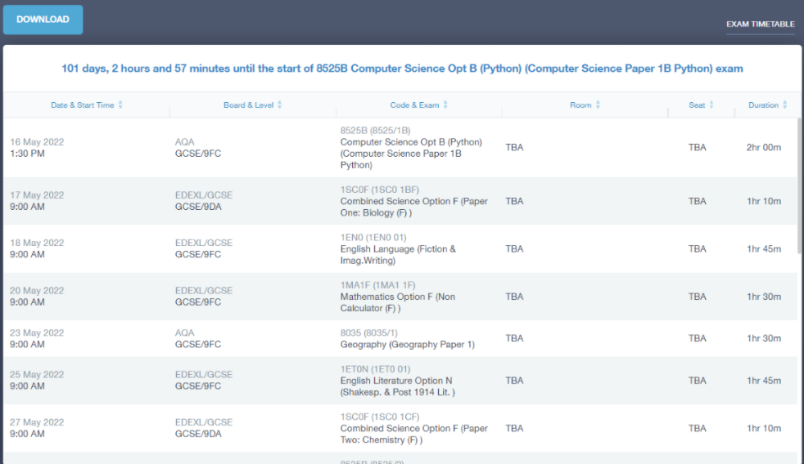

This is what the exam entries page looks like. You can see the exams you are being entered for, which tier level (F = Foundation Tier and H = Higher tier) and which exam board we are using for that subject.
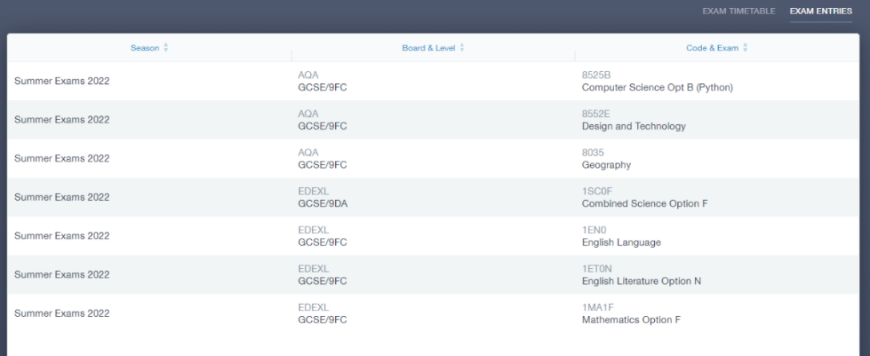

If you have any queries about exam entries, please contact your subject teacher in the first instance.

